**Final Project**

Translunar Free-Return Trajectory of Artemis 2

The City College of New York

Dept. of Mechanical Engineering

ME 51500, Orbital Mechanics

Name: Jeremy Maniago

Instructor: Peter Ganatos

Due Date: 12/11/2023, 5:00pm

**Table of Contents**

Problem Statement 3

Simplifying Assumptions 3

Earth Parking Orbit 4

Systems Checkout 5

Translunar Injection and Trajectory towards Moon Sphere of Influence Patch Point 5

Lunar Fly-by, Moon Centered Frame 7

Lunar Exit, Earth Arrival 7

Earth Splashdown 7

Mission Elapsed Time (MET) 8

References 9

Appendix 9

Optimal Parking Orbit Altitude 9

Parking Orbit, 3 hour system check, and preparation for TLI 12

Transfer from Earth to Moon, Earth Centered Frame 14

Moon-Centered Frame 18

Lunar Exit and Earth return 21

Earth Splashdown 21

Mission Parameters 23

# Problem Statement

This project aims to model a Translunar Free-Return Trajectory and is based on the Artemis 2 mission that will launch by the end of 2024. A free-return trajectory utilizes the moon as a gravity assist to “swing” around back to Earth without requiring additional burn maneuvers. The simplified model of this trajectory is as follows:

1. The Orion spacecraft will launch from Pad 39B at Kennedy Space Center atop a Space Launch System (SLS) rocket.
2. Enter Earth Parking Orbit.
3. Perform a 3-hour systems checkout period in Parking Orbit
4. Fire Interim Cryogenic Propulsion Stage (ICPS), otherwise known as the Translunar Injection (TLI).
5. Enter Moon Sphere of Influence
6. Pass Perilune (Periapsis, aka closest approach to moon)
7. Exit Moon Sphere of Influence
8. Earth Arrival
9. Splashdown

Mission Constraints include:

* Minimization of fuel consumption.
* Achieve Perilune altitude no closer than 100km.
* Accomplish entire mission in 14 days or less.

# Simplifying Assumptions

1. Earth and moon are of finite size.
2. Spacecraft is of infinitesimal size.
3. Earth and moon have coplanar orbits.
   1. Spacecraft and moon have coplanar orbits.
4. Moon’s orbit is nearly circular about the Earth.
5. Parking Orbit is nearly circular about the Earth.
6. Ignore effects of atmospheric drag on launch to Parking Orbit.
7. Ignore effects of drag due to solar radiation pressure.

*Note: All following calculations were done in MATLAB (See Appendix)*

# Earth Parking Orbit

According to online sources, an optimal earth parking orbit altitude for Translunar missions are in Low Earth Orbit (LEO), which range from 160km to 2000km. An analysis of the total $ΔV$ for a Hohmann transfer from Earth radius to different parking orbit analysis shows that LEOs save more velocity impulse, as shown in Figure 1.

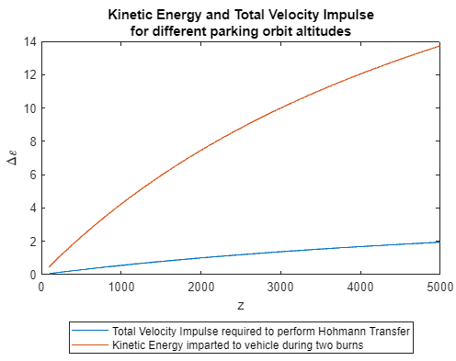

Figure 1: Kinetic Energy and Total Velocity Impulse for various parking orbit altitudes

To narrow down an optimal parking orbit, the Apollo 11 mission was used as reference. The Apollo 11 mission acquired an Earth parking orbit of about 185.9 kilometers. Since Apollo 11 was a successful mission, a parking orbit altitude of 190 kilometers was chosen. Given the altitude, we now have the outer radius, or the apogee radius, of the Hohmann Transfer ellipse. It was calculated that a $ΔV$ of 0.0578 km/s was needed to exit Earth’s radius and a $ΔV$ of 0.0573776 km/s to circularize spacecraft Orion into the 190-kilometer earth parking orbit. It is assumed that the transfer starts at 0 degrees with respect to the earth-moon line and enters parking orbit at 180 degrees with respect to the earth-moon line. The Hohmann transfer takes 0.7198 hours to complete.

# Systems Checkout

The 3-hour systems checkout will occur immediately when Orion achieves earth parking orbit. Calculating that the orbit period of Orion for the 190-kilometer parking orbit is less than 3 hours, it is required that Orion orbits the earth for two and a half times so that the systems checkout can be performed within 3 hours with extra time in case of delays. The total time is then 3 hours + 0.67873 hours, or 3.67873 hours in parking orbit.

# Translunar Injection and Trajectory towards Moon Sphere of Influence Patch Point

The TLI $ΔV$ required to reach the desired patch point is 3.1674 km/s. This is performed at an angle of 0 degrees w.r.t. the earth-moon line at a flight path angle of 0 degrees (tangent to the parking orbit radius). This trajectory takes about 60.67249 hours to complete, with Orion entering the Moon’s Sphere of Influence at an angle of 69 degrees w.r.t. the earth-moon line. An example of this trajectory is shown below.

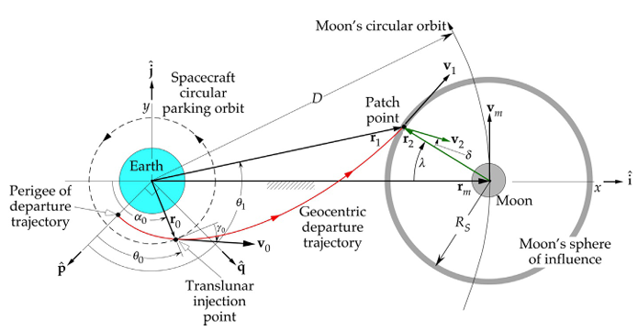

Figure 2: "Coplanar translunar trajectory from earth orbit to crossing of the moon’s sphere of influence. The earth-centered xy axes do not rotate. Not to scale.” – from **Figure 9.2** from referenced book

Orion is launched such that the radius of the earth parking orbit is the perigee radius of the transfer trajectory from Translunar Injection to the Patch point on the Moon’s sphere of influence.

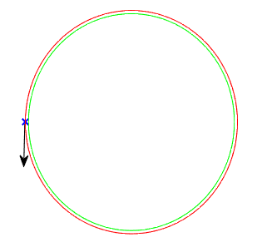

Figure 3: Earth radius (green), Earth parking orbit (red), TLI point (blue x), and direction of TLI (black arrow)

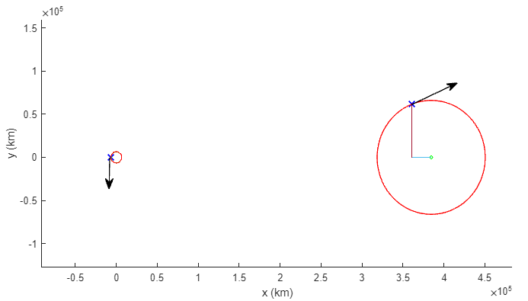

Figure 4: Parking orbit (left, red) to Moon Sphere of Influence (right, red). The Patch points (blue x's) and approximated velocity vectors and directions (black arrows) are shown.

# Lunar Fly-by, Moon Centered Frame

The tangential velocity of the moon can be found given the distance of the moon from the earth. This is needed to find the relative velocity of Orion when it enters the Moon’s Sphere of Influence. Using relations for the Patched Conics Method, a Perilune altitude of 19643.3533 kilometers is achieved, which is far greater than the 100-kilometer lower bound. The time elapsed from the patch point when Orion just enters the Moon’s Sphere of Influence to Perilune is 11.30369 hours.

# Lunar Exit, Earth Arrival

Assuming that the free-return trajectory yields a mirror trajectory of TLI to Perilune, the time elapsed from Perilune to Earth arrival is equivalent. Thus, the total time from TLI to Perilune to Earth arrival is 2*(60.67249 + 11.30369) = 143.95111 hours.

# Earth Splashdown

Assuming an atmospheric drag model with varying density, we can approximate the trajectory of the Orion capsule’s descent into Earth’s atmosphere. Using a heat shield diameter of 5.03 meters, a re-entry mass of 9,300 kilograms, a drag coefficient of 1.5, an initial altitude of 190 kilometers, and an initial velocity of 7.7903 km/s (parking orbit velocity), the trajectory of the capsule can be modelled. From this data, the time elapsed from earth entry to earth splashdown is 0.115585 hours.

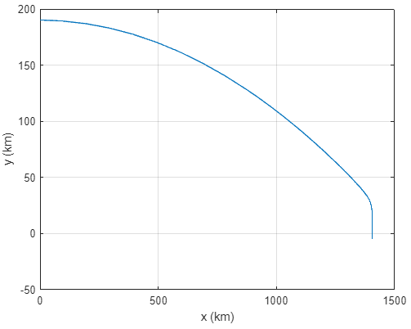

Figure 5: Trajectory of Orion Capsule descending into Earth's atmosphere

# Mission Elapsed Time (MET)

|  |  |  |
| --- | --- | --- |
| Event | MET | Description |
| Launch | 00:00:00 | Launch of Orion Spacecraft |
| Parking Orbit Entrance/Systems-Checkout start | 00:43:11 | Orion enters circularized earth parking orbit of 190 km. Systems-checkout begins |
| Systems-Checkout end | 03:43:11 | Systems-checkout is completed |
| Translunar Injection | 04:23:54 | Translunar Injection of 3.1674 km/s at 0° is performed toward Lunar approach |
| Perilune Approach | 76:22:26 | Orion reaches Perilune altitude of 19643.3533 km |
| Earth Arrival | 148:20:58 | Orion arrives at earth parking orbit altitude of 190 km |
| Earth Splashdown | 148:27:54 | Orion splashes down in one of Earth’s oceans |

Total Mission Time = 6.1861 days > 14 days.

If Orion launches on Friday November 22nd, 2024, at 1:25:60pm, Orion will splashdown on Thursday, November 28th, 2024, at 5:53:40pm. That is *if* Orion launches on this day and that no extra delays due to weather occur.

# References

1. Orbital Mechanics for Engineering Students Chapter 9: Lunar Trajectories, H. Curtis, Elsevier, fourth edition, 2021
2. ME 51500/ME I5800 Lecture Notes, Peter Ganatos, 2023
3. [Apollo 11 Flight Journal - Day 1, part 2: Earth Orbit and Translunar Injection (nasa.gov)](https://history.nasa.gov/afj/ap11fj/02earth-orbit-tli.html#0024416)
4. [Apollo 11's Translunar Trajectory (archive.ph)](https://archive.ph/2014.03.09-220842/http:/www.braeunig.us/apollo/apollo11-TLI.htm)
5. [Free-return trajectory - Wikipedia](https://en.wikipedia.org/wiki/Free-return_trajectory#:~:text=A%20free%2Dreturn%20trajectory%20may,and%20Apollo%2011%20lunar%20missions.)

# Appendix

**Orbital Mechanics Project: Free-Return Trajectory for Earth-Moon Mission**

Code Initiation:

clc

clear

close all

format long

set(0,'DefaultFigureWindowStyle','normal')

## Optimal Parking Orbit Altitude

For Hohmann Transfer between two circular orbits (from earth to parking orbit)

syms dVt dVp dVa ra z e

re = 6378; % km

mu = 3.986e5;

ra = re + z

ra = 

e = (ra - re)/(ra + re)

e =

dVp = sqrt(mu/re)*(sqrt(1 + e) - 1);

dVa = sqrt(mu/ra)*(1 - sqrt(1 - e));

f1 = dVt == abs(dVp) + abs(dVa);

dVt = rhs(f1);

derdVt = diff(dVt, z)

derdVt =

f2 = 0 == derdVt;

x = lhs(f2);

y = rhs(f2);

zs = 100:50:5000;

plot(zs, subs(y, z, zs))

title({'Change of total velocity impulse for Hohmann Transfers', 'over different parking orbit altitudes'})

xlabel('z (km)')

ylabel('$\frac{d\Delta V_{total}}{dz} \ \left(\frac{1}{\rm{s}}\right)$', Interpreter='latex')

plot(zs, subs(dVt, z, zs))

xlabel('z')

ylabel('dVt')

hold on

syms dep

dep = (mu/2)*( (1/re) - (1/ra) )

dep =

plot(zs, subs(dep, z, zs))

title({'Kinetic Energy and Total Velocity Impulse', 'for different parking orbit altitudes'})

xlabel('z')

ylabel('$\Delta \varepsilon$', Interpreter='latex')

legend('Total Velocity Impulse required to perform Hohmann Transfer', 'Kinetic Energy imparted to vehicle during two burns', Location='southoutside')

hold off

Based on online sources, it is generally accepted that the optimal earth parking orbit is in LEO (Low Earth Orbit), which is between 160km - 2000km. Apollo 11 went into a nearly circular earth parking orbit of ~185.9 km. Since that mission was successful, a parking orbit altitude of **190km** will be used. It requires less total velocity impulse to obtain the orbit via Hohmann Transfer compared to higher LEOs, while still being high enough to avoid atmospheric drag.

## Parking Orbit, 3 hour system check, and preparation for TLI

For z = 190km, we can get , , and 

z_val = 190; % km

dVp_val = double(subs(dVp, z, z_val)); dVa_val = double(subs(dVa, z, z_val)); dVt_val = dVp_val + dVa_val;

disp([dVp_val, dVa_val, dVt_val])

0.057800238057830 0.057377600720562 0.115177838778392

po.r = re + z_val;

po.v = sqrt(mu/po.r);

a_transfer = (re + po.r)/2

a_transfer =

6473

Since c , then at z = 190km, the velocity of our spacecraft is . Since we needs a 3-hour system checkout in the parking orbit, we need to make sure that the spacecraft orbits for more than 3 hours

sys_check = 3; % hours

po.T = 2*pi*sqrt((po.r^3)/mu)/ (60*60) % hours

po = struct with fields:

r: 6568

v: 7.790262199699897

T: 1.471493799982799

if (po.T > sys_check)

disp('Proceed')

else

disp('Spacecraft will orbit Earth more than once')

end

Spacecraft will orbit Earth more than once

sys_check/po.T

ans =

2.038744573735254

sys_check - (po.T * 2)

ans =

0.057012400034403

Assuming that the spacecraft launched at the left of the Earth ( w.r.t. the earth-moon line) and the spacecraft reached parking orbit at the right of Earth ( counterclockwise w.r.t. the earth-moon line), the spacecraft must stay in the parking orbit for at least 3 hours, orbiting 2 and a half times if we want to apply TLI at  w.r.t. the earth-moon line.

T.hohmann = pi*sqrt((a_transfer^3)/mu) / (60*60); % hours

T.sys = sys_check;

T.sys_to_tli = (po.T * 2.5) - sys_check

T = struct with fields:

hohmann: 0.719841921782681

sys: 3

sys_to_tli: 0.678734499956997

## Transfer from Earth to Moon, Earth Centered Frame

Find eccentricity of transfer ellipse toward Lunar radius

m.r = 1749; % km, radius of Moon

rp = po.r % Perigee Radius of Transfer Ellipse

rp =

6568

rem = 384400; % Apogee Radius of Transfer Ellipse, which is approximately the

% distance from the earth to the moon

e_em = 1 - rp/rem;

a_em = rp / (1 - e_em); % Semi-major axis of earth-moon transfer ellipse

m.soi = (0.073e24/5.97219e24)^(2/5)*(3.844e5) % Radius of Sphere of Influence of Moon

m = struct with fields:

r: 1749

soi: 6.601750038582264e+04

**Figure 9.2** from *Orbital Mechanics for Engineering Students, Fourth Edition* by Howard D. Curtis:

alpha = 0; % Degrees

gamma = 0; % Degrees

lam = 69; % Degrees (guess value, preferable close to textbook examples and Lecture Notes 17 example)

r0 = [-rp*cosd(alpha) -rp*sind(alpha) 0] % Position Vector of Translunar Injection

r0 = *1×3*

-6568 0 0

r1 = [ rem - m.soi*cosd(lam) m.soi*sind(lam) 0] % Position Vector of Patch Point

r1 = *1×3*

105 ×

3.607414437526267 0.616326461664755 0

x = [r0(1) r1(1)];

y = [r0(2) r1(2)];

fig1 = figure();

fig1.Position(3:4) = [1000, 500];

axis([(-1.0e4)*2 (5.0e5)*2 (-1.0e4) (5.0e5)]);

hold on

plot(x, y, Marker="x", MarkerSize=8, MarkerEdgeColor="b", LineWidth=1.5, LineStyle="none")

te = 0: 180.0 / 50.0: 2.0 * 180.0;

% plot Earth and Moon

plot(re*sind(te), re*cosd(te), 'Color', 'g');

plot(m.r*sind(te) + rem, m.r*cosd(te), 'Color', 'g');

% plot circular earth orbit

plot(rp * sind(te), rp * cosd(te), 'Color', 'r');

% plot Moon SOI

plot((m.soi * sind(te)) + rem, (m.soi * cosd(te)), 'Color', 'r');

plot([rem r1(1)], [0 0])

plot([r1(1) r1(1)], [0 r1(2)])

annotation("arrow", [0.7384 0.8135], [0.644 0.715])

annotation("arrow", [0.2428 0.2416], [0.469 0.3675])

xlim([-91787 483976])

ylim([-127609 160273])

xlabel('x (km)')

ylabel('y (km)')

hold off

Unit vectors of position vectors r0 and r1

r0mag = norm(r0);

u0 = r0/r0mag;

r1mag = norm(r1);

u1 = r1/r1mag;

Sweep angle:

sweep = acosd(dot(u0, u1)) % degrees

sweep =

1.703046324184772e+02

h1 = (sqrt(mu*r0mag))*(sqrt( (1 - cosd(sweep)) / ((r0mag/r1mag) + sind(sweep)*tand(gamma) - cosd(sweep)) ));

Lagrange Coefficients:

f = 1 - (mu*r1mag/(h1^2))*(1 - cosd(sweep));

g = (r0mag*r1mag/h1)*(sind(sweep));

g_dot = 1 - (mu*r0mag/(h1^2))*(1 - cosd(sweep));

Velocity vectors

v0 = (1/g)*(r1 - f.*r0)

v0 = *1×3*

0.000000000000031 10.957628977787843 0

v0mag = norm(v0)

v0mag =

10.957628977787843

vr0 = dot(v0, u0);

v1 = (1/g)*(g_dot.*r1 - r0)

v1 = *1×3*

0.932727152883535 -0.040148601701853 0

v1mag = norm(v1)

v1mag =

0.933590837543321

vr1 = dot(v1, u1);

dV0 = sqrt(po.v^2 + v0mag^2 - 2*po.v*v0mag*cosd(gamma)) % Delta V (TLI)

dV0 =

3.167366778087945

e1 = (1/mu)*((v0mag^2 - (mu/r0mag))*r0 - r0mag*vr0*v0); % Eccentricity vector of translunar trajectory

e1mag = norm(e1) % Eccentricity of translunar trajectory

e1mag =

0.978468008850911

Perifocal Unit Vectors

p1 = e1/e1mag;

w1 = cross(r1, v1)/h1;

q1 = cross(w1, p1);

a1 = (h1^2/mu)*(1/(1 - (e1mag)^2)) % Semimajor axis of transfer ellipse

a1 =

3.050344928401090e+05

T1 = 2*pi*sqrt((a1^3)/mu) % Period of Translunar Trajectory in Seconds

T1 =

1.676620023006308e+06

theta0 = acosd(dot(p1, u0));

theta1 = theta0 + sweep;

Time of TLI and time of arrival at patch point:

Tterm = T1/(2*pi);

eterm = sqrt((1 - e1mag)/(1 + e1mag));

term0 = 2*atan(eterm*tand(theta0/2));

t0 = Tterm*( term0 - (e1mag*sin(term0)) );

term1 = 2*atan(eterm*tand(theta1/2));

t1 = Tterm*( term1 - (e1mag*sin(term1)) );

T.tli = t1 - t0

T = struct with fields:

hohmann: 0.719841921782681

sys: 3

sys_to_tli: 0.678734499956997

tli: 2.184209472894811e+05

Here,  because we applied TLI at 

## Moon-Centered Frame

Now we can treat this problem like a Lunar Flyby.

m.mu = 4.90487e3; % Gravitational Parameter of Moon

The angular speed of the Moon w.r.t to the Earth can be estimated to be the tangential velocity for a rotating frame and assuming a circular orbit

m.V = [0 sqrt(mu/rem) 0]

m = struct with fields:

r: 1749

soi: 6.601750038582264e+04

mu: 4.904870000000000e+03

V: [0 1.018302846300942 0]

Velocity at arrival point relative to the Moon

r2 = [ -m.soi*cosd(lam) m.soi*sind(lam) 0] % Position Vector of Lunar Arrival relative to Moon

r2 = *1×3*

104 ×

-2.365855624737333 6.163264616647548 0

r2mag = norm(r2);

u2 = r2/r2mag; % Unit Vector of r2

v2 = v1 - m.V

v2 = *1×3*

0.932727152883535 -1.058451448002795 0

v2mag = norm(v2)

v2mag =

1.410779716860658

vr2 = dot(v2, u2);

h2 = cross(r2, v2);

h2mag = norm(h2);

e2 = ((cross(v2, h2))/m.mu) - u2;

e2mag = norm(e2) % eccentricity of hyperbola

e2mag =

9.032513345826672

Perilune Radius and Altitude

m.rp = ((h2mag^2)/m.mu)*(1/(1+ e2mag))

m = struct with fields:

r: 1749

soi: 6.601750038582264e+04

mu: 4.904870000000000e+03

V: [0 1.018302846300942 0]

rp: 2.139235332970537e+04

m.z = m.rp - m.r;

disp("Perilune Altitude = " + m.z + " > 100km")

Perilune Altitude = 19643.3533 > 100km

Perifocal Unit Vector

p2 = (e2/e2mag);

True anomaly of patch point on lunar approach hyperbola, measured positive clockwise from perilune

theta2 = 360 - acosd(dot(p2, u2))

theta2 =

2.844304377804260e+02

Time relative to Perilune at patch point

one = (h2mag^3)/((m.mu^2)*(((e2mag^2) - 1)^(3/2)));

e2term = sqrt((e2mag - 1)/(e2mag + 1));

term2 = 2*atanh(e2term*tand(theta2/2));

t2 = one*( (e2mag*sinh(term2)) - 2*term2 )

t2 =

-4.069105014836327e+04

Since this is time *until* Perilune, the elapsed time from the Patch Point to Perilune is

T.perilune = 0 - t2

T = struct with fields:

hohmann: 0.719841921782681

sys: 3

sys_to_tli: 0.678734499956997

tli: 2.184209472894811e+05

perilune: 4.069105014836327e+04

## Lunar Exit and Earth return

T.tli = T.tli/(60*60); % hours

T.perilune = T.perilune/(60*60); % hours

Assuming that the return trajectory is a mirror of the approach trajectory, then the time elapsed from TLI to Earth Orbit Return is

T.translunar = 2*(T.tli + T.perilune)

T = struct with fields:

hohmann: 0.719841921782681

sys: 3

sys_to_tli: 0.678734499956997

tli: 60.672485358189185

perilune: 11.303069485656463

translunar: 1.439511096876913e+02

## Earth Splashdown

Assume that the spacecraft has

global beta rho0 H ge

A = 19.87e-6;

ms = 9300;

Cd = 1.5

Cd =

1.500000000000000

rho0 = 1.28e9;

H = 9;

y0 = 190;

gamma = 0;

v0 = po.v; % assume parking orbit velocity as initial velocity

ge = 9.81e-3;

beta = (Cd*A)/(2*ms);

tspan = [0 500];

yi = [v0*cosd(gamma) v0*sind(gamma) 0 y0];

[ts, y] = ode45(@yprime, tspan, yi);

fig2 = figure();

plot(y(:, 3), y(:, 4))

xlabel('x (km)')

ylabel('y (km)')

grid

T.splashdown = ts(148) / (60*60)

T = struct with fields:

hohmann: 0.719841921782681

sys: 3

sys_to_tli: 0.678734499956997

tli: 60.672485358189185

perilune: 11.303069485656463

translunar: 1.439511096876913e+02

splashdown: 0.115585012672365

## Mission Parameters

T.total = T.hohmann + T.sys + T.sys_to_tli + T.translunar + T.splashdown;

total = T.total / 24;

T.begin = caldays(0) + hours(0.0);

T.launch = time(T.begin);

T.parking = time(T.begin + hours(T.hohmann));

T.system_check_end = T.parking + hours(T.sys);

T.TranslunarInjection = T.system_check_end + hours(T.sys_to_tli);

T.Perilune = T.TranslunarInjection + hours(T.tli) + hours(T.perilune);

T.EarthArrival = T.TranslunarInjection + hours(T.translunar);

T.Splashdown = T.EarthArrival + hours(T.splashdown);

fields = {'hohmann', 'sys', 'sys_to_tli', 'tli', 'perilune', 'translunar', 'splashdown', 'total'};

T = rmfield(T, fields);

T

T = struct with fields:

begin: 0d

launch: 00:00:00

parking: 00:43:11

system_check_end: 03:43:11

TranslunarInjection: 04:23:54

Perilune: 76:22:26

EarthArrival: 148:20:58

Splashdown: 148:27:54

disp("Total Mission time = " + total + " days")

Total Mission time = 6.1861 days

disp("Delta V required for Translunar Injection Burn = " + dV0 + " km/s at a flight path angle of " + gamma + " degrees")

Delta V required for Translunar Injection Burn = 3.1674 km/s at a flight path angle of 0 degrees

disp("Altitude of Perilune Approach = " + m.z + " km")

Altitude of Perilune Approach = 19643.3533 km

function yp = yprime(ts,y)

global beta rho0 H ge

rho = rho0*exp(-y(4)/H);

v = sqrt(y(1)^2 + y(2)^2);

yp = [-beta*rho*v*y(1);

-beta*rho*v*y(2) - ge;

y(1);

y(2)];

end